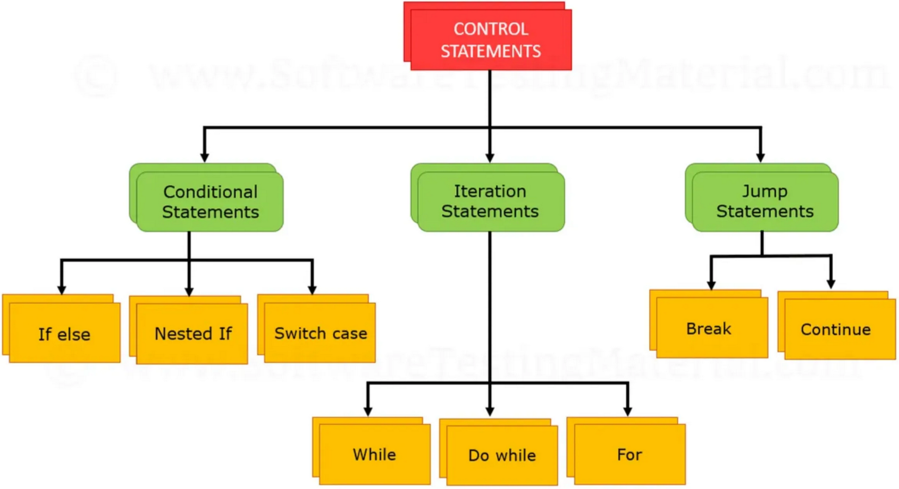

* Control Flow
* if, else, switch
* Loops: for, while, do-while
* **break**,** continue**,** goto**